Problem 1 - Install oh-my-zsh

sudo apt-get update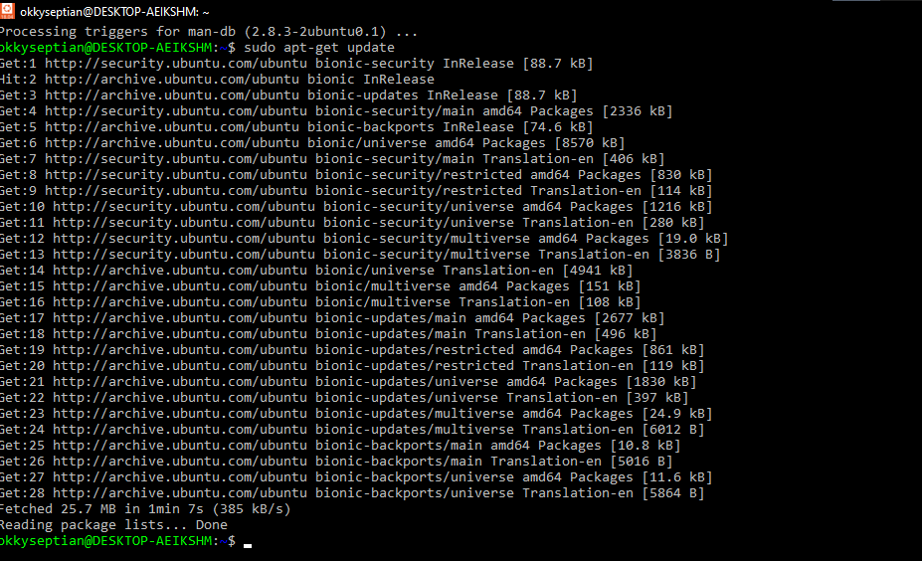

sudo apt upgrade

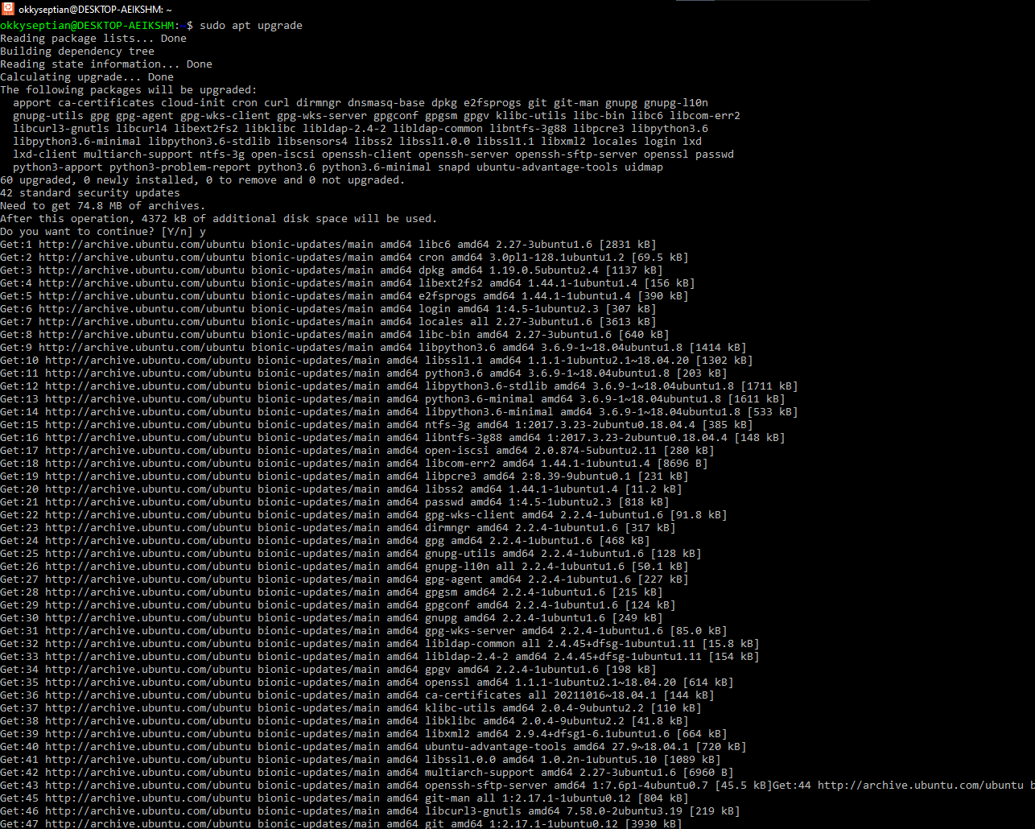

sudo apt install zsh

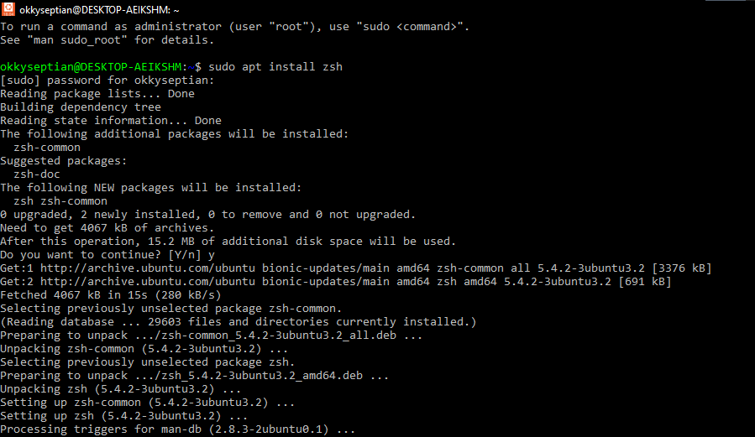

sudo apt-get install powerline fonts-powerline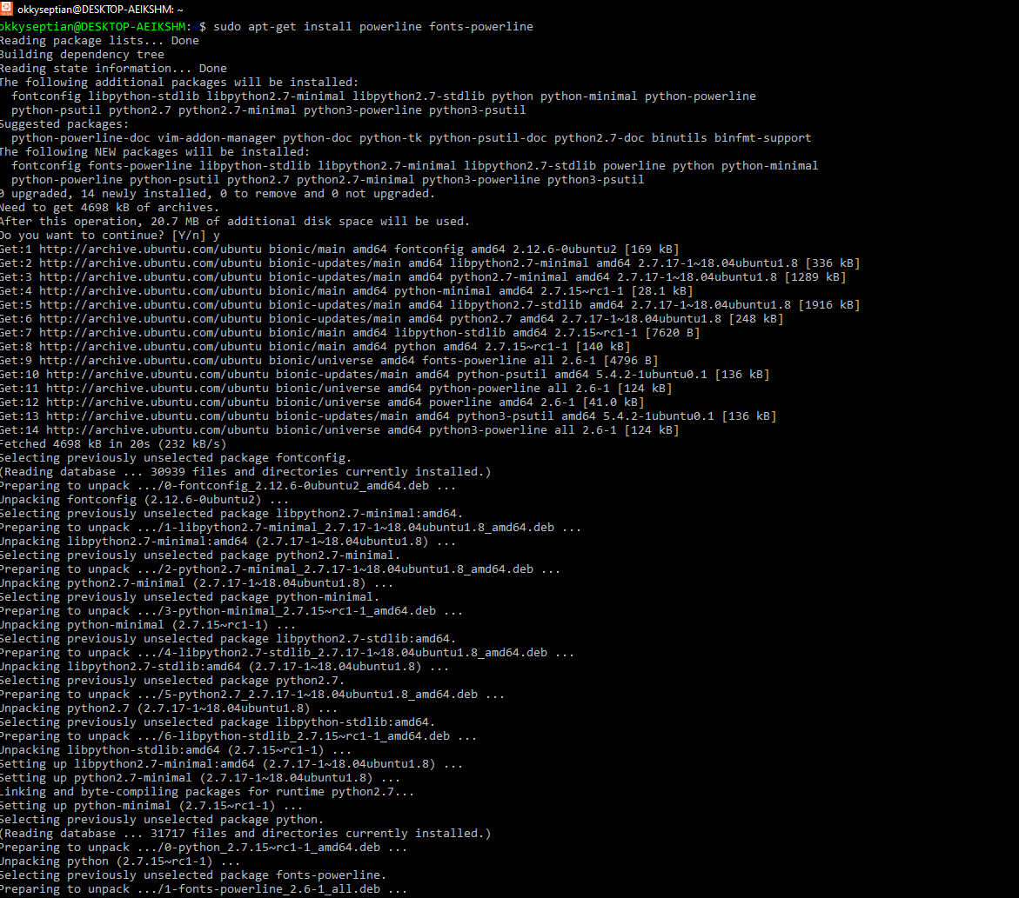

git clone https://github.com/robbyrussell/oh-my-zsh.git ~/.oh-my-zsh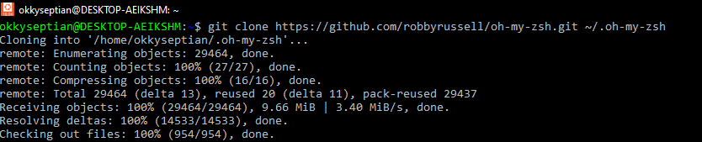

cp ~/.oh-my-zsh/templates/zshrc.zsh-template ~/.zshrc

nano .zshrc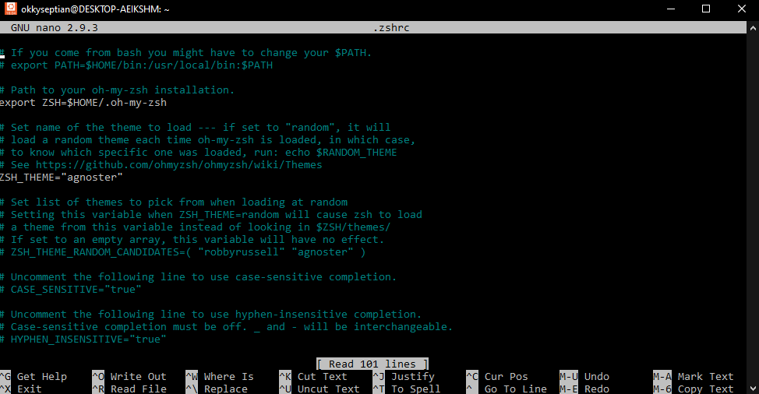

ZSH_THEME="agnoster"

chsh -s /bin/zsh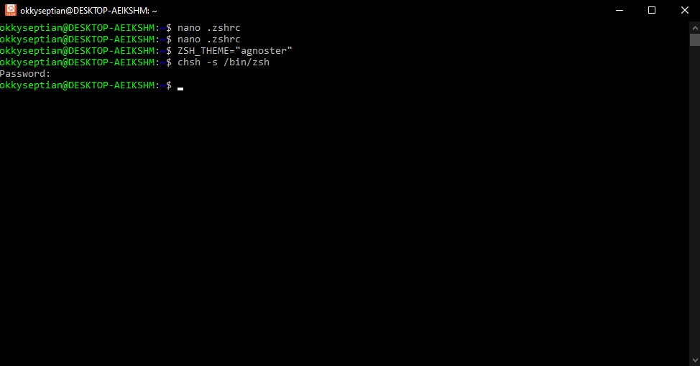

cd .oh-my-zsh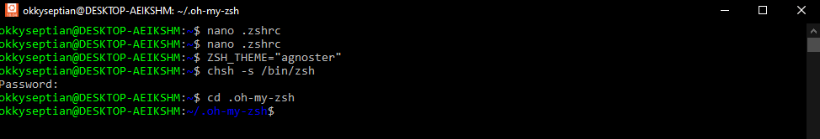

Clone the ZSH Syntax Highlighting 